Software Requirement Specifications

AI-Based Image-Based Motorcycle Helmet Detection

Submitted by
Hassan Javed(S23BINFT1M01011)
Submitted to
Mr. Munawar Ahmad

Department of Information Technology
Faculty of Computing
The Islamia University of Bahawalpur

Meeting Details
Sr No | Details | Date | Supervisor Signature

Summary
This document presents a detailed Software Requirements Specification (SRS) for the AI-Based Image-Based Motorcycle Helmet Detection System. The purpose of this system is to automate the process of identifying whether motorcycle riders are wearing helmets by using advanced image processing and deep learning techniques.
The proposed system is designed to work with both images and live video streams captured through CCTV cameras or other recording devices installed on roads. It first detects motorcycles and riders in the input frame and then analyzes each rider to determine whether a helmet is being worn or not.
Using trained deep learning models, the system classifies each detected rider into two categories: “Helmet” or “No Helmet.” If a rider is found without a helmet, the system automatically marks it as a violation. Along with detection, the system also captures and stores evidence such as images, timestamps, and location data for further review.This recorded data can be used by traffic authorities for monitoring, reporting, and taking necessary legal actions against traffic violations. The system is intended to reduce manual monitoring efforts and improve efficiency in traffic law enforcement.
Overall, this solution contributes to road safety by encouraging helmet usage, reducing the risk of serious injuries in accidents, and supporting law enforcement agencies in implementing traffic rules more effectively. The system is designed to be fast, reliable, automated, and scalable so that it can be deployed in real-world smart city environments.
Table of Contents
1. Introduction 5
1.1. Purpose 5
1.2. Product Perspective 5
1.3. User Characteristics 6
1.4. Similar apps and systems/Literature Review 7
1.5. Proposed Technologies 7
2. Requirements 9
2.1. Function Requirements 9
2.1.1.FR001-Motorcycle Detection 9
2.1.2.FR002-Helmet Classification 9
2.1.3.FR003-Real Time Video Processing 10
2.1.4.FR004-Violation Alert Generation 11
2.1.5.FR005-Result Display&Logging 11
2.2. Non-Functional Requirements 12
3. Use Cases and Flow of Processes 13
3.1. Use Case 1:Motorcycle Detection 13
3.2. Use Case 2:Helmet Classification 16
3.3. Use Case 3:Violation Detection & Alert Generation 19
3.4. Use Case 4:Real Time Video Processing 21
3.5. Use Case 5:Result Display & Logging 23
4. References 25

- Introduction
A significant safety concern is the rising incidence of traffic accidents caused by riders who are not wearing helmets. Conventional traffic police surveillance is labor-intensive, time-consuming, and ineffective.The project suggests an AI-based solution that uses deep learning and image processing to automatically identify helmet use. Without the need for human participation, the system detects infractions in real-time or using archived photos or videos.

  - Purpose

The purpose of this project is to design and develop an intelligent image-based system that automatically detects whether motorcycle riders are wearing helmets using deep learning techniques. The system aims to enhance road safety by identifying helmet violations in real time or from stored images and assisting traffic authorities in enforcing safety regulations.Additionally, the system seeks to reduce manual monitoring efforts, improve detection accuracy, and provide a reliable and efficient solution for tracking and managing helmet compliance. It also helps in maintaining digital records of violations, which can be used for reporting and analysis.

  - Product Perspective
The proposed Motorcycle Helmet Detection System is a standalone AI-based
application designed to automatically detect helmet usage among motorcycle riders.
The system can operate independently or be integrated with existing traffic
monitoring and surveillance systems.It consists of multiple components including a
camera module (CCTV or webcam) for capturing images or live video, a
processing unit that runs deep learning models for detection and classification, and
a storage system for saving violation records.
The system processes input data in real-time or from stored media and identifies
whether a rider is wearing a helmet or not.
Optionally, the system may include a simple dashboard interface for administrators
or traffic authorities to view detection results, monitor violations, and generate
reports. This product provides an efficient and automated alternative to manual
traffic monitoring systems, improving accuracy and reducing human effort.
  - User Characteristics
• Administrator:
Has full control over the system, including managing system settings, viewing violation records, and generating reports. The administrator may also manage data storage and system configurations. Basic technical knowledge is required.
• Traffic Authority:
Responsible for monitoring helmet violations and using the system reports for enforcement purposes. They interact with the system to view detected violations and analyze data. Basic system interaction knowledge is required.
• System (AI Model):
Acts as an automated user that performs detection tasks without human intervention. It processes images or video input, identifies motorcycles and riders, and determines whether a helmet is present. No manual input is required for its operation.
  - Similar apps and systems/Literature Review
Motorcycle helmet detection has been widely studied using computer vision and
deep learning techniques to improve road safety and automate traffic monitoring.
- YOLO-based systems are the most commonly used, providing real-time
detection of riders with or without helmets using CCTV footage. Models like
YOLOv5 and YOLOv8 are popular due to their high accuracy and speed.
- CNN-based approaches were used earlier for classifying helmet and no-
helmet images, but they are less effective in real-time environments.
- Hybrid systems combine helmet detection with license plate recognition
(OCR) to automatically identify traffic violations.
- Traditional image processing methods (like edge detection and Haar
cascades) are now outdated due to low accuracy in complex traffic conditions.
  - Proposed Technologies
The system will be implemented using the following technologies:

1. Programming Language
- Python
Used for model development, training, and integration due to its simplicity and strong AI ecosystem.

2. Deep Learning Frameworks
- TensorFlow / PyTorch
Used to build, train, and optimize deep learning models for object detection.

3. Object Detection Model
- YOLO (You Only Look Once) – YOLOv5 / YOLOv8
Used for real-time detection of motorcycles and helmet/no-helmet classification.

4. Computer Vision Library
- OpenCV
Used for image processing, video handling, and real-time camera feed analysis.

5. Dataset Source
- Kaggle / Roboflow / Custom Dataset
Used for training and testing the model with labeled helmet and non-helmet images.
6. Development Environment
- VS Code
Used for coding, training models, and testing outputs.

7. Version Control
- Git & GitHub
Used for project tracking, collaboration, and code management.

8. Optional Tools
- LabelImg / Roboflow Annotator → for dataset labeling
- CUDA (GPU support) → for faster model training
- Requirements
The system will provide functionalities related to motorcycle detection, helmet and
no-helmet classification, real-time video processing, alert generation, and result
visualization.

2.1. Function Requirements
These requirements directly in the with functions which are already provided.

2.1.1. FR001 – Motorcycle Detection
Purpose:
To detect motorcycles in images or video feed
User(s):
System / Admin
Input:
- Image or live video feed
Processing:
- Capture frame from input source
- Detect motorcycle using YOLO model
- Draw bounding box around detected motorcycle
Output:
- Motorcycle detected or not detected result

2.1.2. FR002 – Helmet Classification
Purpose:
To classify rider as helmet or no-helmet
User(s):
System / Traffic Authority
Input:
- Detected motorcycle region
Processing:
- Extract rider area
- Apply trained YOLO model
- Classify helmet or no helmet
Output:
- Label: “Helmet” or “No Helmet”

2.1.3. FR003 – Real-Time Video Processing
Purpose:
To process live CCTV or webcam feed
User(s):
System
Input:
- Live video stream
Processing:
- Continuously read frames
- Run detection model on each frame
- Update results in real-time
Output:
- Live detection results displayed on screen

2.1.4. FR004 – Violation Alert Generation

Purpose:
To generate alerts for traffic violations
User(s):
Traffic Authority / System
Input:
- “No Helmet” detection result
Processing:
- Check detection output
- Trigger alert mechanism
Output:
- Alert message or log for violation

2.1.5. FR005 – Result Display & Logging
Purpose:
To display and store detection results
User(s):
Admin
Input:
- Detection results
Processing:
- Store results in file/database
- Display annotated output
Output:
- Saved logs and visual output with bounding boxes

2.2. Non-Functional Requirements
The system will ensure the following quality and performance requirements:
- NFR001 – Performance Requirement
The system should process images and video frames in real-time with minimal delay.
- NFR002 – Accuracy Requirement
The system should provide high detection accuracy for both motorcycle detection and helmet classification.
- NFR003 – Reliability Requirement
The system should consistently perform detection without frequent failures under normal operating conditions.
- NFR004 – Scalability Requirement
The system should support multiple video streams or camera inputs if expanded in future.
- NFR005 – Robustness Requirement
The system should work effectively under different lighting conditions, angles, and
- partial occlusions.
- NFR006 – Usability Requirement
The system should have a simple interface that is easy to operate for users and administrators.
- NFR007 – Maintainability Requirement
The system should be easy to update, debug, and improve by modifying the model or codebase.

3. Use Cases and Flow of Processes

Use cases are the formal representation of process flow defined by functional requirements.

3.1. Use Case 1: Motorcycle Detection
ID:UC001
Name: Motorcycle Detection
Description: This use case describes the process of detecting motorcycles in an image or video stream.
Requirement(s): FR001
Actor(s): System / Admin
Precondition: System is running and camera or image input is available
Postcondition: Motorcycle is successfully detected and highlighted

Basic Flow
- System starts camera or loads input image/video
- System reads frames from input source
- System applies YOLO model for object detection
- System identifies motorcycle in the frame
- System draws bounding box around detected motorcycle
- System displays detection result on screen

Alternative Flow
- System retries detection if object is not clearly visible
- System processes next frame if detection fails in current frame

Exceptions
- Camera not working
- No object detected in frame
- Low-quality input image/video

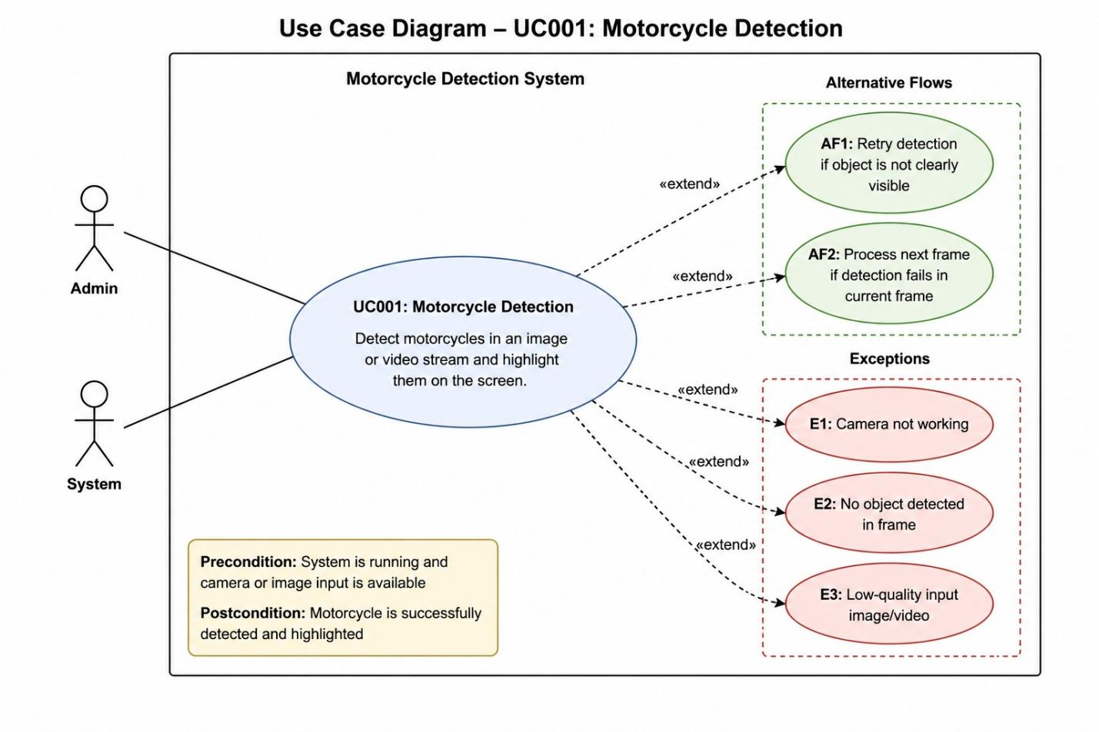

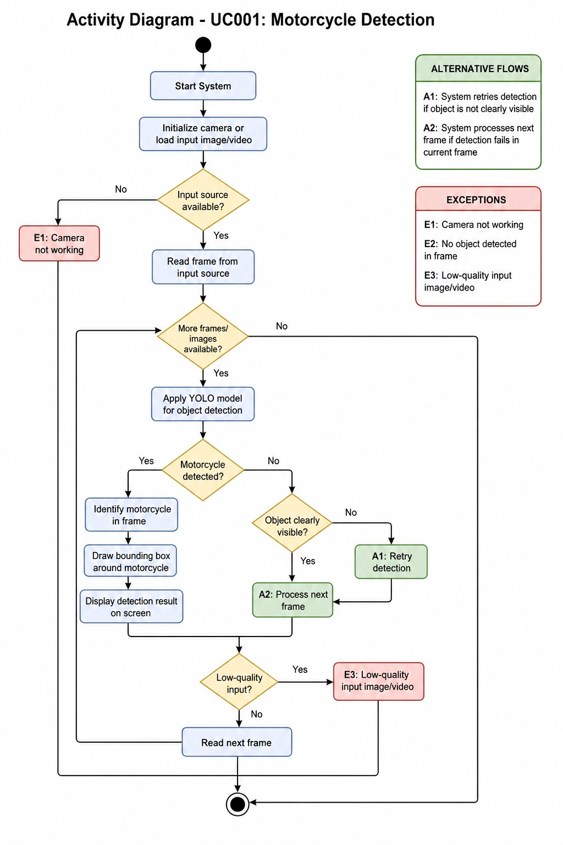

3.2. Use Case 2: Helmet Classification

ID: UC002

Name: Helmet Classification

Description: This use case describes the process of classifying rider as helmet or no-helmet

Requirement(s): FR00

Actor(s): System / Traffic Authority
Precondition: Motorcycle is already detected
Postcondition: Rider is classified as Helmet or No Helmet

Basic Flow
- System extracts rider region from detected motorcycle
- System processes rider image using trained YOLO model
- System analyzes helmet presence
- System classifies result as Helmet or No Helmet
- System displays classification result

Alternative Flow
- System re-analyzes frame if detection confidence is low
- System waits for clearer frame for reclassification

Exceptions
- Rider not clearly visible
- Occlusion or overlapping objects
- Poor lighting conditions
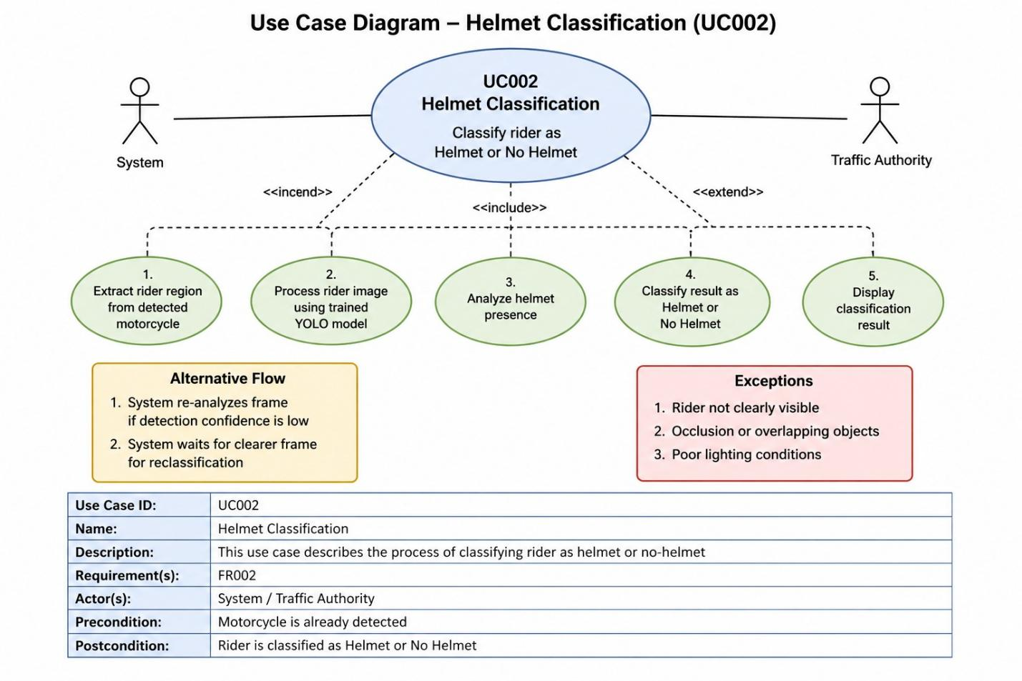
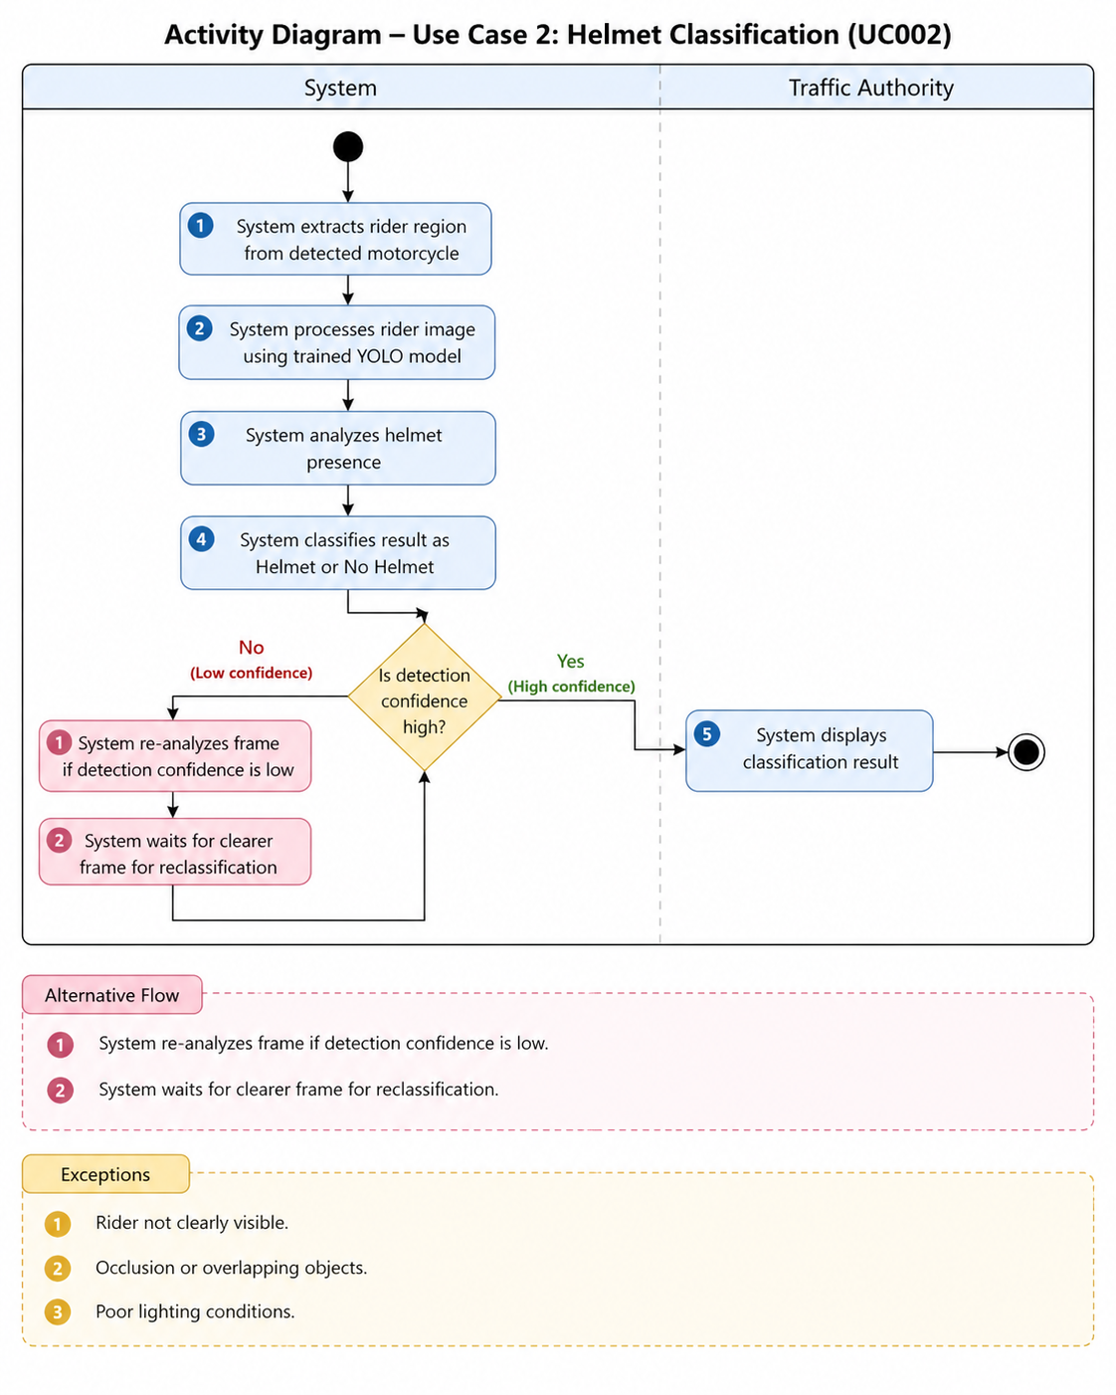

3.3. Use Case 3: Violation Detection & Alert Generation
ID: UC003
Name: Violation Detection
Description: This use case describes detecting traffic violations (No Helmet cases) and generating alerts
Requirement(s): FR003
Actor(s): System / Traffic Authority
Precondition: Helmet classification is completed
Postcondition: Violation is logged and alert is generated

Basic Flow
- System receives classification result
- System checks if result is “No Helmet”
- System triggers alert mechanism
- System logs violation details
- System displays alert message

Alternative Flow
- System ignores alert if Helmet is detected
- System continues monitoring next frame

Exceptions
- System failure during alert generation
- Incorrect classification result
- Data logging error
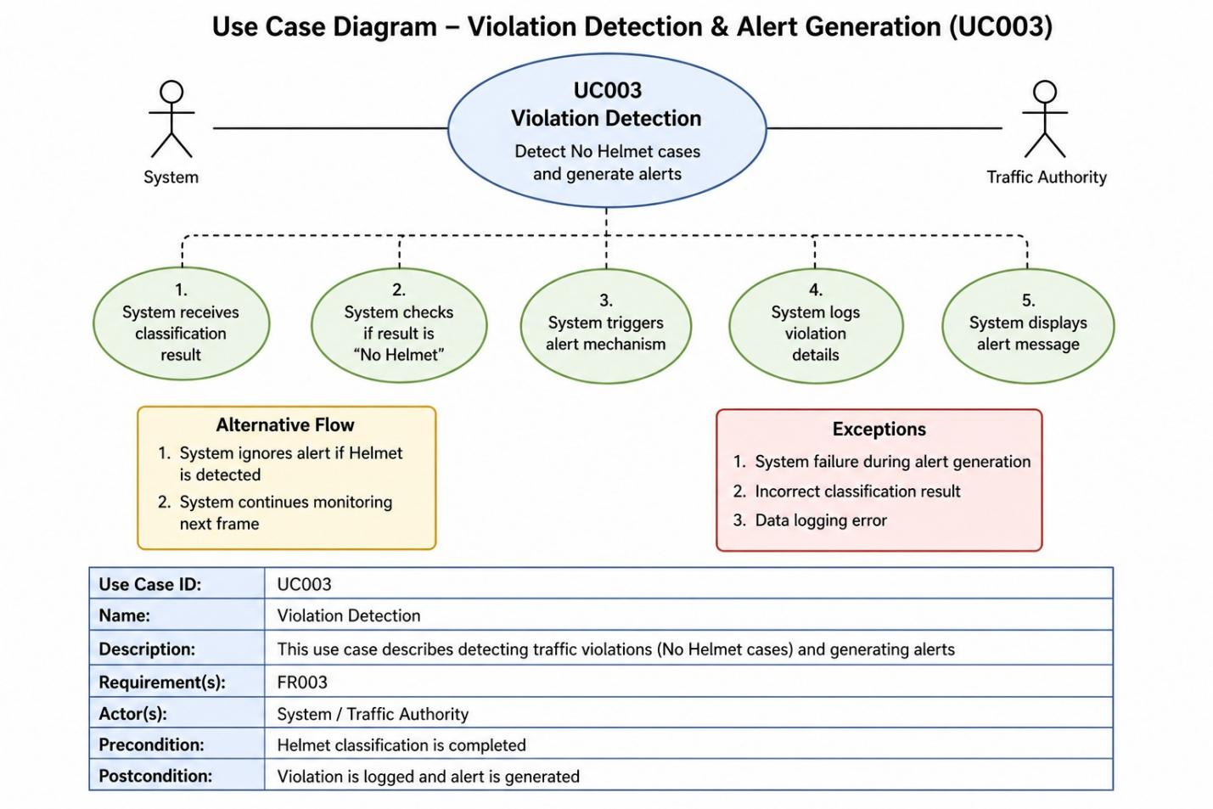
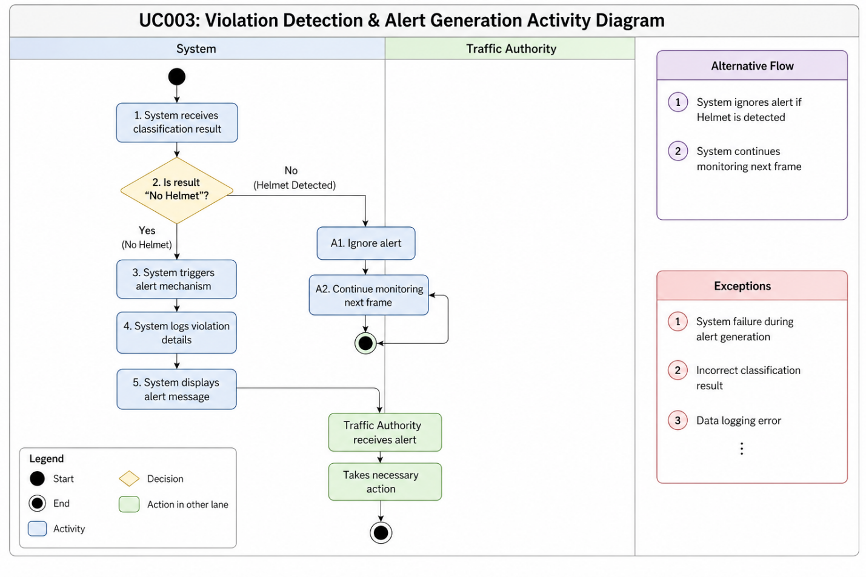

3.4. Use Case 4: Real-Time Video Processing
ID: UC004
Name: Real-Time Monitoring
Description: This use case describes continuous processing of live video feed
Requirement(s): FR004
Actor(s): System
Precondition: Camera feed is active
Postcondition: Continuous detection is performed

Basic Flow
- System starts live video stream
- System reads frames continuously
- System performs detection on each frame
- System updates results in real-time
- System displays output with annotations

Alternative Flow
- System skips frame if processing delay occurs
- System resumes processing automatically

Exceptions
- Camera disconnection
- Frame lag or delay
- System overload
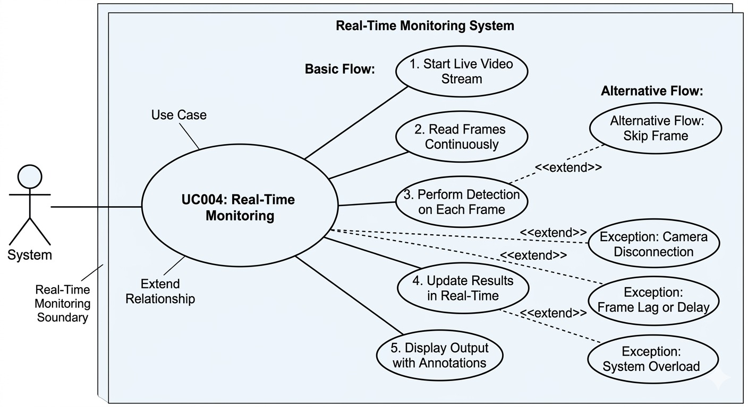
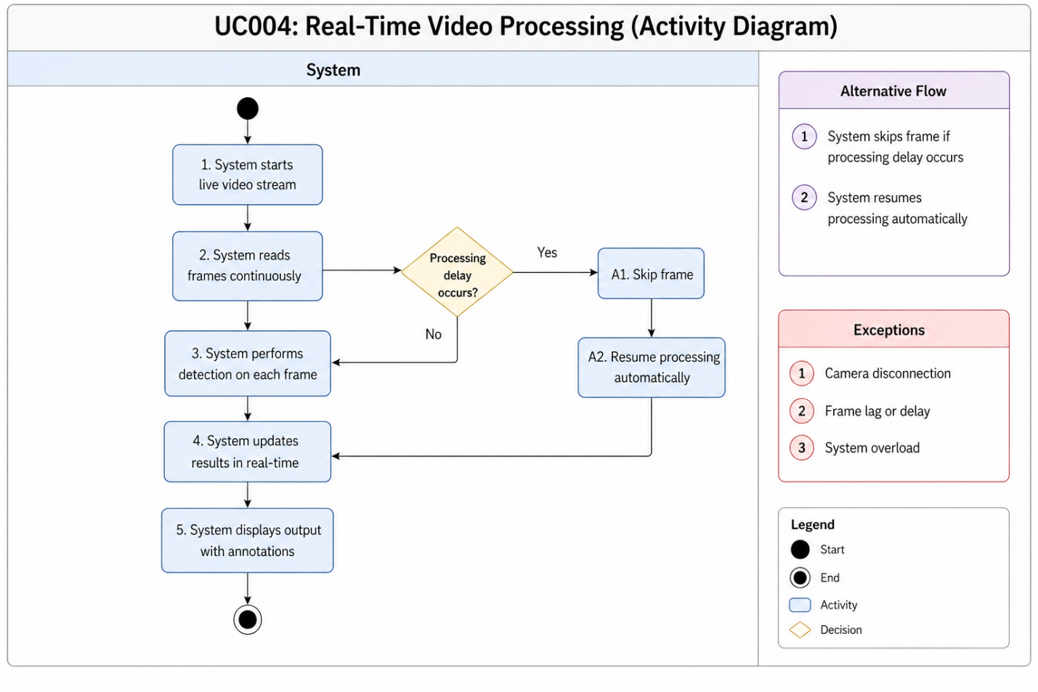

3.5. Use Case 5: Result Display & Logging
ID: UC005
Name: Result Display & Logging
Description: This use case describes how the system displays detection results to the user and stores them in logs for future reference and analysis.
Requirement(s): FR005
Actor(s): System
Precondition: Image/video processing is completed successfully
Postcondition: Results are displayed and stored in the database/log file

Basic Flow
- System completes helmet detection processing on input image/video frame
- System generates prediction results (Helmet / No Helmet)
- System displays results on the user interface
- System highlights detected objects using bounding boxes and labels
- System saves detection results with timestamp in log/database
- System confirms successful logging of results

Alternative Flow
- System displays only visual results without logging if storage is temporarily unavailable
- System stores logs in local memory and syncs later when database connection is restored

Exceptions
- Database connection failure during logging
- System crash before saving results
- Corrupted or incomplete detection output
- Insufficient storage space for logs
- UI display failure or rendering delay
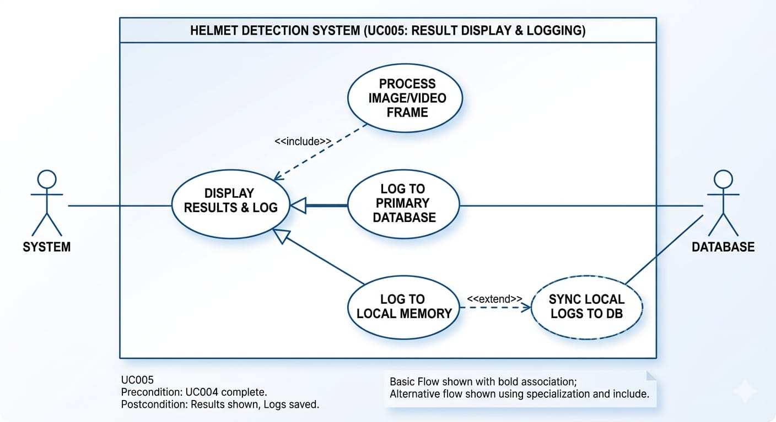

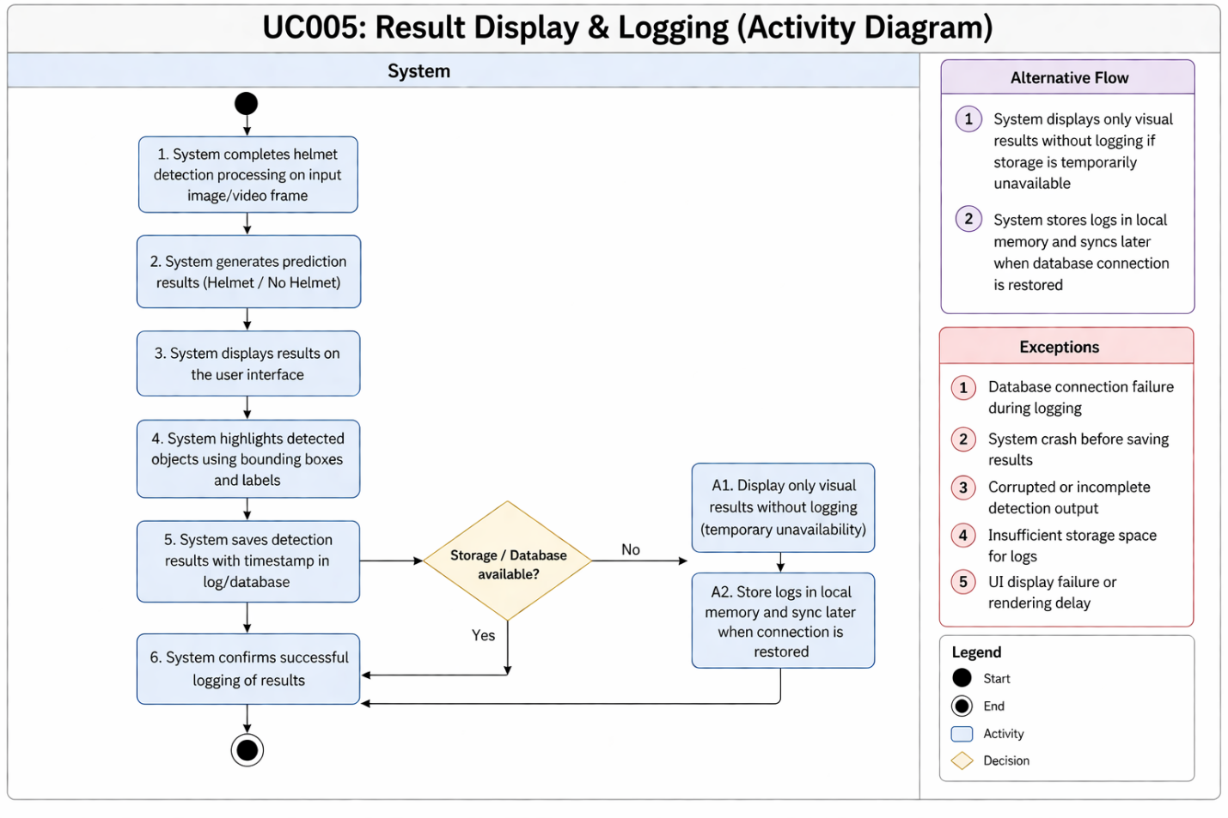

4. References

IEEE References
- J. Redmon, S. Divvala, R. Girshick, and A. Farhadi,
“You Only Look Once: Unified, Real-Time Object Detection,”
Proceedings of the IEEE Conference on Computer Vision and Pattern Recognition (CVPR), 2016.
Link: https://arxiv.org/abs/1506.02640
- G. Jocher et al.,
“YOLOv5 by Ultralytics,” 2023.
Link: https://github.com/ultralytics/yolov5
- M. Abadi et al.,
“TensorFlow: A System for Large-Scale Machine Learning,”
USENIX Symposium on Operating Systems Design and Implementation, 2016.
Link: https://www.tensorflow.org
- A. Paszke et al.,
“PyTorch: An Imperative Style, High-Performance Deep Learning Library,”
Neural Information Processing Systems (NeurIPS), 2019.
Link: https://pytorch.org
- G. Bradski,
“The OpenCV Library,”
Dr. Dobb’s Journal of Software Tools, 2000.
Link: https://opencv.org
- Y. LeCun, Y. Bengio, and G. Hinton,
“Deep Learning,”
Nature, vol. 521, pp. 436–444, 2015.
Link: https://www.nature.com/articles/nature14539
- R. Silva et al.,
“Automatic Detection of Motorcyclists without Helmet,”
IEEE Latin America Transactions, 2018.
- K. Dahiya, D. Singh, and C. K. Mohan,
“Automatic Detection of Helmet Use for Motorcyclists,”
IEEE Intelligent Transportation Systems Conference, 2020.

